|  |
| --- |
|  |
| Year 12 Physics |
| Excursion workbook |
| Your visit to ANSTO  On site, you will visit:   * OPAL (Open Pool Australian Lightwater) Research Reactor * Australian Centre for Neutron Scattering * Centre for Accelerator Science * ANSTO Nuclear Medicine Facility   Back at the Discovery Centre, you will:   * observe a demonstration using a scintillation counter to investigate the properties of alpha, beta and gamma radiation * investigate how radiation varies with distance from a source, and with shielding thickness. * investigate how half-life of a radioisotope is determined experimentally * examine the interconnectedness of the concepts of the law of conservation of energy, mass defect, binding energy and Einstein’s mass–energy equivalence relationship 𝐸 = 𝑚𝑐2, and the application of these concepts in nuclear processes * explore an analogy of binding energy * evaluate a model of the process of nuclear fission * explore ANSTO’s science work, future directions of nuclear technology and nuclear waste management.   The tour will conclude at the Discovery Centre. |
|  |
|  |

Year 12 Physics: Nuclear Science Depth Study

We recommend that this excursion becomes the starting point for a nuclear science depth study. ANSTO’s Year 12 Physics excursion assists students in covering the following syllabus content:

**Module 8: From the Universe to the Atom**

Students:

* analyse the spontaneous decay of unstable nuclei, and the properties of the alpha, beta and gamma radiation emitted (ACSPH028, ACSPH030)
* examine the model of half-life in radioactive decay and make quantitative predictions about the activity or amount of a radioactive sample using the following relationships:

Nt = N0e-λt

λ = ln(2)/t1/2

where Nt = number of particles at time t, N0 = number of particles present at t = 0, λ = decay constant, t1/2 = time for half the radioactive amount to decay.

* model and explain the process of nuclear fission, including the concepts of controlled and uncontrolled chain reactions, and account for the release of energy in the process
* analyse relationships that represent conservation of mass-energy in spontaneous and artificial nuclear transmutations, including alpha decay, beta decay, nuclear fission and nuclear fusion
* account for the release of energy in the process of nuclear fusion
* predict quantitatively the energy released in nuclear decays or transmutations, including nuclear fission and nuclear fusion, by applying:

– the law of conservation of energy

– mass defect

– binding energy

– Einstein’s mass–energy equivalence relationship 𝐸 = 𝑚𝑐2

* investigate the operation and role of particle accelerators in obtaining evidence that tests and/or validates aspects of theories, including the Standard Model of matter

**Working Scientifically**

* Questioning and predicting
* Planning investigations
* Conducting investigations

We recommend students use our *Year 12 Physics Depth Study Guide* for ideas and resources for depth study activities after their excursion.

## NESA requirements for Depth Studies

* A minimum of 15 hours of in-class time is allocated in both Year 11 and Year 12
* At least one depth study must be included in both Year 11 and Year 12
* The two Working Scientifically outcomes of Questioning and Predicting, and Communicating must be addressed in both Year 11 and Year 12
* A minimum of two additional Working Scientifically skills outcomes, and further development of at least one Knowledge and Understanding outcome, are to be addressed in all depth studies.

# Pre-work Questions – to be attempted *before* your visit

## Question P1

Use the online Atom Builder program (<https://www.ansto.gov.au/education/apps>) and the Periodic Table poster (<https://www.ansto.gov.au/education/resources/posters>) to help complete the table.

|  |  |  |  |  |
| --- | --- | --- | --- | --- |
| Name of atom | Number of protons | Number of neutrons | Mass number | Notation |
| nitrogen-14 |  |  |  |  |
|  | 3 |  | 7 |  |
|  |  |  |  |  |
|  |  | 14 | 27 |  |

## 

## Question P2

Most unstable nuclei with a large number of protons (more than 82) decay via alpha radiation. Nuclei with too many neutrons, when compared to the stable isotopes of that element, decay via negative beta (β-) radiation, while those with too few neutrons often decay by positron emission (β+). State the common stable isotope of each element and use it to predict the type of radiation produced when the following nuclei decay:

|  |  |  |
| --- | --- | --- |
| Unstable isotope | Common stable isotope  of element | Type of radiation produced during nuclear decay of unstable isotope |
| 1. C-14 |  |  |
| 1. U-238 |  |  |
| 1. F-18 |  |  |
| 1. Co-60 |  |  |
| 1. I-131 |  |  |

## Question P3

Answer the following questions using the information in the table below:

|  |  |  |  |  |
| --- | --- | --- | --- | --- |
| **Name of radiation** | **Identity of radiation** | **Penetration through matter (energy dependent)** | **Ionising power** | **Behaviour of path in magnetic field** |
| Alpha (α) | Helium nucleus (two protons and two neutrons) | Very weak; average alpha can only penetrate about 5cm through air, stopped by a sheet of paper or skin | Produce high ionisation | Show deflection in strong magnetic fields due to positive charge |
| Beta (β) | Negative β; electron  (an anti-neutrino is also emitted during negative beta decay)  positive β; positron  (a neutrino is also emitted during positive beta decay) | Moderate; penetrate about 1-2m through air, stopped by a few mm of aluminium or perspex | Produce moderate ionisation | Easily deflected by magnetic fields due to negative charge (negative β) or a positive charge (positive β) |
| Gamma (γ) | Very high frequency electromagnetic radiation | Very powerful penetration; not really completely stopped by anything. Higher energy rays are reduced 50% by 12mm of lead | Very weak effect in causing ionisation | Not deflected by magnetic fields, exhibit no electric charge |

1. A student has a sample of radioactive material. They find that when a Scintillation counter is held about 20 cm from the sample the count recorded is very low, but when they bring the counter very close to the sample, high counts are detected. Outline one conclusion the student might make about the radioactive material.

___________________________________________________________

__________________________________________________________

__________________________________________________________

1. Smoke detectors contain a small sample of a radioisotope that emits radiation into a narrow air gap between two electrodes. The air is ionised and completes an electric circuit. When smoke enters this air gap, fewer air particles are ionised and the current drops, activating the alarm. Identify the form of radiation that would be emitted from the radioactive element used in a smoke detector. Give reasons for your answer.

___________________________________________________________

__________________________________________________________

__________________________________________________________

## Question P4

A cloud chamber is a good way to show the background radiation which is present in our environment. It consists of a sealed container, enclosing a [supersaturated](https://en.wikipedia.org/wiki/Supersaturation) alcohol vapour. As the ionising radiation passes through, it knocks the electrons out of the atoms in the air molecules, resulting in a trail of ionized gas particles. Alcohol molecules, which are neutral, are attracted to the ions and condense on the charged particles, leaving a trail of droplets indicating the path of the ionising radiation. These tracks disappear almost immediately.

When you are ANSTO make sure you take a look at our cloud chamber!

The charged particles which produce tracks in a cloud chamber are alpha and beta particles (from radioactive atoms), and protons and muons (from space). Muons are leptons with a charge equal to that of an electron, but they are about 200 times heavier. They have a half-life of 2.2 microseconds (µs). They are produced about 15 km above the surface of Earth and travel at 0.99C (2.99 x108 ms-1).

At this speed, we expect them to take [ sec = 50 µs to reach us. This is around 20 times their ½ life: hence fewer than 1 in a million should survive.

However, we usually see some muons in our cloud chamber.

Suggest a plausible explanation for their appearance at the Earth’s surface.

_________________________________________________________________________

_________________________________________________________________________

_________________________________________________________________________

_________________________________________________________________________

_________________________________________________________________________

## Question P5

The following table shows some information on the radioactive decay of several radioisotopes. Use the ANSTO periodic table of the elements (<https://www.ansto.gov.au/education/resources/posters>) to help you fill in the missing details

|  |  |  |
| --- | --- | --- |
| Radioactive parent isotope | Products of decay of parent nucleus | |
| Daughter element | Symbol for radiation emitted |
|  |  |  |
|  |  |  |
|  |  |  |
|  |  |  |
|  |  |  |
|  |  |  |

## Question P6

The following equation allows you to quantitatively predict the remaining radioactivity of a sample using its half-life:

Nt = N0e-λt

λ =

where Nt = number of particles at time t, N0 = number of particles present at t = 0, λ = decay constant, t1/2 = time for half the radioactive amount to decay.

1. The half-life of the isotope U-238 is 4.51 x 109 years. The age of the Earth is estimated to be about 4.6 x 109 years. Based on this, predict what proportion of this isotope of uranium would be found on Earth today compared to when the Earth first formed (Nt/N0).

___________________________________________________________

__________________________________________________________

__________________________________________________________

___________________________________________________________

__________________________________________________________

__________________________________________________________

1. Carbon-14 is a naturally occurring isotope of carbon that is radioactive. All living things absorb carbon from the environment while they are alive, and then stop taking it in when they die. By analysing the carbon found in ancient remains derived from once living things, the ratio of C-14 to other isotopes of carbon (C-12 or C-13) in the sample can reveal the age of an artefact up to 50,000 years old. Carbon-14 has a half-life of about 5,730 years.

An ancient wooden artefact from a human settlement contains about 12.5% of the C-14 that would be expected if it were alive in the environment today. Based on this result, calculate an approximate age for the ancient artefact.

___________________________________________________________

__________________________________________________________

__________________________________________________________

___________________________________________________________

__________________________________________________________

__________________________________________________________

**Question P7**

Fission in a nuclear reactor is controlled, whereas fission in a nuclear weapon is uncontrolled. Controlled fission in a reactor requires:

* The correct **fuel** composition, usually a mixture of fissionable U-235 and non-fissionable U-238.
* A **moderator** to slow the speed of the neutrons from the fission reaction, increasing the chance that neutrons are absorbed by neighbouring uranium nuclei for further fission events.
* **Control rods**, which, when inserted into the reactor core, regulate the number of neutrons available to create fission events via neutron capture.
* **Coolant and heat exchangers** to cool the core to prevent overheating.

Isotopes have different properties when they interact with neutrons. When a neutron encounters the nucleus of different isotopes either

* + the neutron can bounce off the nucleus or
  + the neutron is captured by the nucleus, with three different results possible:

1. the neutron capture results in fission of the nucleus, or
2. the neutron capture results in a new, neutron-rich radioactive nucleus, or
3. the neutron capture results in a new stable isotope forming.

Identify which of these properties an isotope would need to have for it to be a good choice to use in a nuclear fission reactor as:

1. the fuel __________________________________________________________
2. the moderator _____________________________________________________
3. the control rods ____________________________________________________

# *On-site tour –* During excursion questions

# *Your Education Officer will provide you with information from which you will be required to select and process the appropriate material to answer these questions.*

## Question T1 – OPAL research reactor

Label the diagram and complete the table below:

## 

|  |  |  |
| --- | --- | --- |
| **Material** | **Reactor component** | **Function** |
| Heavy water |  |  |
| Hafnium  (encased in stainless steel) |  |  |
| Light water |  |  |
| Uranium |  |  |

## Question T2 – Australian Centre for Neutron Scattering

1. Identify three properties of neutrons that make them suitable for studying materials. Explain how each property allows scientists to use neutrons as a probe for investigating matter.

|  |  |
| --- | --- |
| Property of neutrons | How property enables investigation of matter |
|  |  |
|  |  |
|  |  |

1. Why does ANSTO use both thermal and cold neutrons?

___________________________________________________________

__________________________________________________________

__________________________________________________________

1. Summarise one example of neutron research

___________________________________________________________

__________________________________________________________

__________________________________________________________

___________________________________________________________

__________________________________________________________

__________________________________________________________

## Question T3 – ANSTO Nuclear Medicine Facility

1. If technetium-99m is the radioisotope used for diagnostic scans, why does ANSTO manufacture and distribute molybdenum-99? Consider the half-life of each isotope.

___________________________________________________________

__________________________________________________________

__________________________________________________________

1. Target plates are very radioactive when they come out of the reactor. Describe two safety measures used to work safely with radiation during the manufacture and distribution of molybdenum-99
2. ________________________________________________________________

___________________________________________________________________

1. ________________________________________________________________

___________________________________________________________________

1. What are the benefits of Synroc as a waste storage solution?

___________________________________________________________

__________________________________________________________

__________________________________________________________

___________________________________________________________

__________________________________________________________

__________________________________________________________

## Question T4 – Centre for Accelerator Science

1. a) Choose from the following list to label the parts of the tandem accelerator

shown in the diagram below.

*positive high voltage terminal, steel pressure tank, pelletron charging chain, evacuated accelerator beam tube, stripping chamber, equipotential rings, magnet.*

1. Indicate the **flow** **direction** (using arrows) and **charge** (positive or negative) of the ions shown by on the diagram.

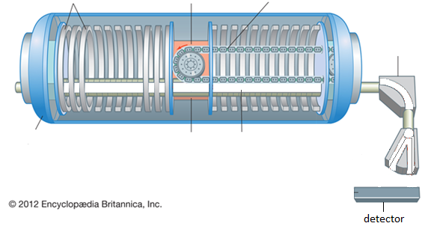

## 

## In the tandem accelerator, what is the purpose of each of the following:

|  |  |
| --- | --- |
| electric field |  |
| magnetic field |  |

## *At the Discovery Centre:*

**Activity 1: Investigating the properties of alpha, beta and gamma radiation**

1. View the demonstration and record the radioactivity measured by the scintillation counter in each of the following situations.

|  |  |  |  |  |
| --- | --- | --- | --- | --- |
| Source | Radioactivity (counts per second) | | | |
| No cover | Paper | Aluminium | Lead |
| A |  |  |  |  |
| B |  |  |  |  |
| C |  |  |  |  |

1. Use the data you have recorded to identify the type of radiation produced by each source. Justify your choice.

|  |  |  |
| --- | --- | --- |
| Source | Type of radiation | Justification: Why do you think it is this radiation? |
| A |  |  |
| B |  |  |
| C |  |  |

1. Gamma emission usually accompanies alpha or beta decay. Which other form of radiation do you think is being emitted from the gamma source? Give a reason for your answer.

__________________________________________________________________________________________________________________________________________________

_________________________________________________________________________

## Activity 2: How radioactivity changes with distance

We will be using **radioactive sources and** a **scintillation counter** to detect radiation (alpha, beta and gamma) coming from a source.

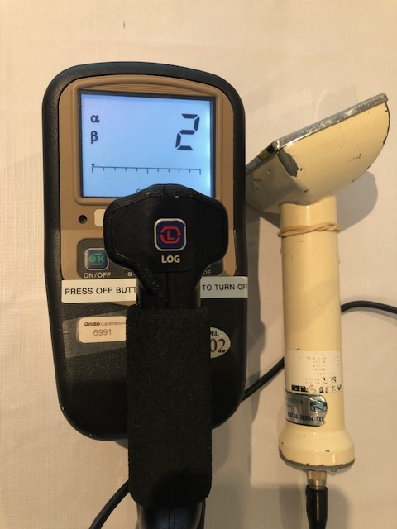 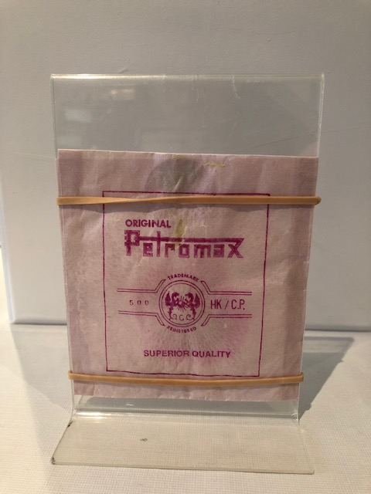

The radioactive sources are low level activity sources, and a short amount of exposure time will not cause any harm. Some sources are contained inside a plastic or wax bag and, to prevent inhalation and transfer to hands of any radioactive material, they must **not to be removed from the bag.**

Use this information to complete the risk assessment:

|  |  |
| --- | --- |
| Risk | Way to minimize this risk |
|  |  |
|  |  |
|  |  |

Record the measurement of the radioactivity as the scintillation detector is moved different distances from the source.

On the grid provided, sketch a graph to illustrate how radioactivity changes with distance from the source.



|  |  |
| --- | --- |
| Distance from source  (cm) | Radioactivity  (counts per second, cps) |
| 0 |  |
| 1 |  |
| 2 |  |
| 4 |  |
| 8 |  |
| 16 |  |
| 32 |  |

## Activity 3: How Radioactivity changes with thickness of a shielding material

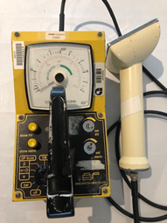

Is the scale of an analogue (dial) scintillation counter linear?

(**HINT**: consider the radioactive decay equation)

_________________________________________________________________________________________________________________________________________________________

Record the measurement of the radioactivity as the thickness of the paper shielding material between the source and the detector is increased.

On the grid provided, sketch a graph to illustrate how radioactivity from the source changes with the thickness of the paper shielding.



|  |  |
| --- | --- |
| Thickness of paper shielding  (mm) | Radioactivity  (counts per second, cps) |
| 0 |  |
| 1 |  |
| 2 |  |
| 4 |  |
| 7 |  |
| 10 |  |

Is the change linear?

_________________________________________________________________________

## Activity 4:Modelling the process of nuclear fission

The core of ANSTO’s OPAL reactor contains around 30 kg of uranium. 19.75% of this uranium is the fissionable Uranium-235, the rest is the other naturally occurring isotope, Uranium-238, which absorbs neutrons.

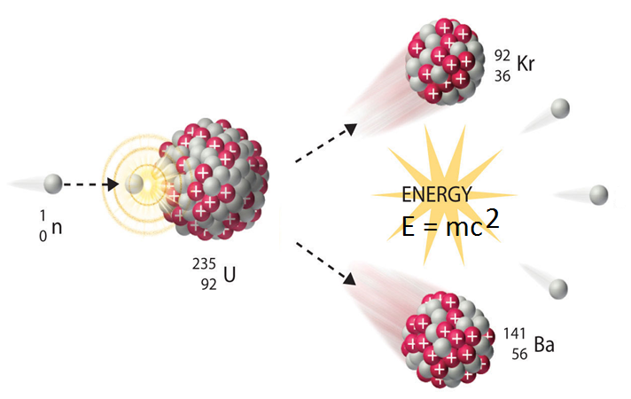

Two or three high energy, high speed neutrons are produced

Thermal neutron

View ANSTO’s animation of the fission process. This animation can also be found at

[OPAL research reactor animation - YouTube](https://www.youtube.com/watch?v=GooWJywwfgo&t=2s) (from 0.45 – 1.21 min)

Consider the information about the process of fission in the OPAL reactor that you have heard on site, and the information provided above, to evaluate the animation model of the fission process.

1. Is this a controlled or uncontrolled reaction of nuclear fission? Why?

__________________________________________________________________________________________________________________________________________________

1. What does this animation model show about the process of nuclear fission in our OPAL nuclear reactor?

__________________________________________________________________________________________________________________________________________________

__________________________________________________________________________________________________________________________________________________

1. What are the limitations of this model of nuclear fission for our OPAL nuclear reactor? What is missing from this model?

__________________________________________________________________________________________________________________________________________________

__________________________________________________________________________________________________________________________________________________

## Activity 5:Binding Energy analogy

This analogy compares magnets, which have their north poles covered with Velcro, with positively charged protons in the nucleus.

1. a. Describe what happens when the north poles of the magnets are brought towards

each other.

__________________________________________________________________________________________________________________________________________________

b. Name the force that is causing this effect. ________________________________________

1. Describe what happens when the north poles of the magnets are brought very close together so that they touch.

__________________________________________________________________________________________________________________________________________________

1. What fundamental force do you think is represented by the Velcro? Give a reason for your answer.

__________________________________________________________________________________________________________________________________________________

1. What is the name given to the energy you need to add and pull the protons (magnets) apart to separate them?

_________________________________________________________________________________

1. Complete the following table to summarise the two main forces operating in the nucleus:

|  |  |  |
| --- | --- | --- |
| Force | Nucleons between which the force acts | Distance over which force acts |
| Electromagnetic |  |  |
| Strong nuclear |  |  |

**Post Presentation Activities**

**Question 1: Radioactive Decay**

During the presentation you viewed a video showing how the activity of a radiopharmaceutical was measured over time using a dose calibrator. The data shown in the table below was recorded for a radiopharmaceutical of the radioisotope technetium-99m.

On the grid below, plot the data and use your graph to determine the half-life of technetium-99m.

|  |  |
| --- | --- |
| The radioactive decay of technetium-99m | |
| Time  (hours) | Activity (Megabequerel, MBq) |
| 0 | 1250 |
| 0.25 | 1215 |
| 0.5 | 1180 |
| 0.75 | 1146 |
| 1 | 1114 |
| 2 | 992 |
| 4 | 788 |
| 24 | 78 |



Half-life of technetium-99m ……………………………………………….

**Question 2: Radioactive Decay Law**

The following equation, known as the **radioactive decay law**, allows you to quantitatively predict the amount of a radioactive sample that still remains and has not yet decayed after a time *t,* where

Nt = number of radioactive nuclei present at time *t,* and N0 = the initial number of radioactive nuclei present (that is, at *t* = 0)

Nt = N0e-λt

The number of radioactive nuclei present at time *t* (Nt) is proportional to the level of radioactivity of the source. Hence the radioactive decay law can also be represented by

At = A0e-λt

where λ = ln(2)

t1/2

where At = the activity of the sample at time t,

A0 = the initial activity of the sample that is the activity at t = 0,

λ = decay constant,

t1/2 = time for half the radioactive amount to decay,

ln 2 (the natural log of 2) equals 0.693.

1. For the radionuclide technetium-99m, use the table on the previous page to state the activity (At) after the number of stated hours in the table below to calculate the half-life of the technetium-99m.

|  |  |  |  |
| --- | --- | --- | --- |
| Number of hours (x) | Initial activity  (Ao) | Activity after x hours (At) | calculated half life |
| 1 |  |  |  |
| 4 |  |  |  |

1. Compare the values of the half-life determined for each of the number of hours. Comment on the accuracy of the values.

…………………………………………………………………………………………………………………………………………………………………………………………………………………………………………………………………………………………………………………………

1. How might a more accurate value be determined?

………………………………………………………………………………………………………………………………………………………………………………………………………………………………………………………………………………………………………………………….

…………………………………………………………………………………………………………………………………………………………………………………………………………………………………………………………………………………………………………………………

**Question 3: Binding Energy**

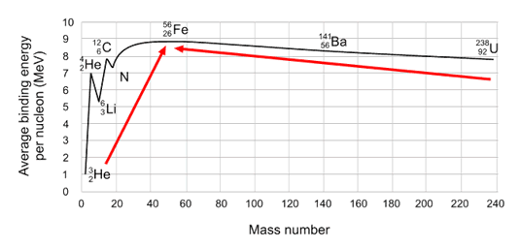

Source: [Radioactivity | ARPANSA](https://www.arpansa.gov.au/understanding-radiation/what-is-radiation/ionising-radiation/radioactivity)

1. The diagram shows the binding energy per nucleon for atoms of different elements.

Determine the binding energy, in Joules, for the most stable nucleus, an isotope of iron,

where 1 eV = 1.602 x 10-19 J

(**HINT**: Use the graph to estimate the binding energy per nucleon for iron-56)

___________________________________________________________

__________________________________________________________

__________________________________________________________

___________________________________________________________

1. Nuclear fusion of hydrogen in the core of the Sun can be summarised by the following equation:

4β

The information below shows the mass of the various components in the equation. The masses are given in atomic mass units (u), where 1.0 u = 1.6605 x 10-27 kg

Rest mass of proton (hydrogen nucleus) = 1.007267 u

Rest mass of helium nucleus = 4.001506 u

Rest mass of positron = 0.0005486 u

Rest mass of neutrino = ~ 0.0000 u

1. Determine the mass of the reactants and the mass of the products, and then use them to calculate the amount of mass lost (mass defect) in this solar reaction.

___________________________________________________________

__________________________________________________________

__________________________________________________________

1. Using Einstein’s equation E=mc2, calculate the energy in joules released from

this fusion reaction. (Note: The mass must be in kg before you use the equation.)

___________________________________________________________

__________________________________________________________

__________________________________________________________

1. The natural radioisotope, radium-226, undergoes a radioactive decay where it emits an alpha particle to become radon-222. The mass of the radium-226 nucleus is 226.0254 u and the α-particle has a mass of 4.001506 u. If the α-particle is ejected with a kinetic energy of 7.665 x 10-13 J, and you assume it receives all the energy produced by the decay, explain how the mass of the radon-222 nucleus could be determined, and calculate a result in atomic mass units. Be sure to use masses in kg.

(Note: In the actual decay of a Ra-226 nucleus, the alpha particle does not really receive all the energy involved, because a gamma ray is also released).

___________________________________________________________

__________________________________________________________

__________________________________________________________

___________________________________________________________

__________________________________________________________

___________________________________________________________

1. Different fission fragments are produced during the fission of uranium-235. Fill in the blanks in the example fission equation below:
2. The fission of one uranium-235 nucleus yields an average energy of about 200MeV = 3.2 x 10-14J. Considering that 1.0kg of pure uranium-235 contains approximately 2.56 x 1024 uranium atoms, calculate the total energy released, in joules, if the nucleus of every atom in the 1.0kg of uranium undergoes fission.

__________________________________________________________

___________________________________________________________

1. The average winter electricity consumption for a Sydney household is 1700 kWh (Source: [AER’s 2020 Residential Energy Consumption Benchmarks Report](https://www.google.com.au/search?q=Residential%20energy%20consumption%20benchmarks%20-%209%20December%202020_0.pdf)). Theoretically, how many households would be able to be maintained over winter from the energy produced by the fission of 1.0 kg of uranium-235?

(**HINT**: 1 kWh = 3.6 x 106 J)

__________________________________________________________

___________________________________________________________

**Further ANSTO Resources for Year 12 Physics**

ANSTO has collaborated with Associate Professor Geoff Currie to develop a [Data sets | ANSTO](https://www.ansto.gov.au/education/resources/data-sets) resource Radionuclides in Nuclear Medicine which includes activities to use MS Excel to construct and analyse graphs of authentic data for the activity of 3 different radionuclides over time to determine the half-life of each unknown medical radionuclide.

Viewing the following videos will also help you to get the most out of our ANSTO Year 12 Physics Excursion (<https://www.youtube.com/user/ANSTOVideos>):

* [OPAL research reactor animation](https://www.youtube.com/watch?v=GooWJywwfgo):This video provides an overview of the structure and functions of the OPAL nuclear reactor.
* [Echidna: High speed powder diffractometer](https://www.youtube.com/watch?v=wP7r81ryuww): This video shows how neutrons from inside the OPAL reactor are used in neutron diffraction instruments to study material structure at the atomic level.
* [Safely managing Australia’s radioactive waste:](https://www.youtube.com/watch?v=X-xK95vygkM) Nuclear research and medicine produced by ANSTO has benefited generations of Australians since the 1960s. With benefits, come responsibilities, and the by-products of nuclear research and medicine includes radioactive waste. ANSTO responsibly manages this waste in both the long and short term.