Exploring what scientists do
Applying the processes of scientific inquiry
Student Worksheet

This resource has been developed in conjunction with Jack Simmons, Associate Research Fellow at the Centre for Atmospheric Chemistry, University of Wollongong. ANSTO would like to express sincere appreciation to Jack Simmons for his invaluable and substantial contribution.

This resource, with its accompanying MS Excel workbook ‘Atmospheric Measurements at Liverpool Girls HS’, give students an opportunity to engage in scientific inquiry through the application of working scientifically skills. The document provides a systematic, step by step scaffold of a scientific investigation using secondary data of atmospheric measurements recorded in an MS Excel spreadsheet. The measurements were made using a NSW Department of Planning, Industry and Environment (DPIE) Air Quality Monitoring Station (AQMS) and an ANSTO 1500L dual-flow-loop two-filter radon (²²²Rn) detector on the grounds of Liverpool Girls High School, from March 2019 to February 2020.

The tasks in the document require student access to a computer with internet capability and the spreadsheet program Microsoft Excel. Students are guided through gathering and processing background information, analysing the secondary data provided in the MS Excel spreadsheet, and reporting on the scientific investigation.

The station installation, where the data for this resource was collected, and ongoing maintenance was a combined effort between staff at DPIE (then the Office of Environment and Heritage), the University of Wollongong Centre for Atmospheric Chemistry, the Australian Nuclear Science and Technology Organisation (ANSTO), Liverpool Girls High School and the NSW Department of Education. The authors would like to acknowledge all who assisted in making this possible.

This resource was created for use by students in Years 7-10.

Students will:
- propose an hypothesis after researching relevant background information
- process and analyse data and information
- create a graph and interpret results
- communicate the process and findings of their investigation in the form of a scientific report
- increase their understanding of the atmosphere and the factors that influence it

The scaffold provided for the scientific report of the investigation is based on the structure indicated in Investigation Report work samples from the Australian Curriculum Assessment and Reporting Authority (ACARA), and from information provided on the Scientific Research Report for the NESA Science Extension course. This is also in agreement with the structure of a practical report provided on the Victoria State Government Education and Training website. Links to these resources are provided below:

- Rates of reaction – AT | The Australian Curriculum
- Bouncing balls – AT | The Australian Curriculum
- Scientific research report | NSW Education Standards
- Science: putting it together (education.vic.gov.au)

This resource has been designed to address the following Science Understanding and Inquiry Skills descriptors in the Australian curriculum.

Students:
- formulate questions or hypotheses that can be investigated scientifically (ACSIS164/198)
- analyse patterns and trends in data, including describing relationships between variables and identifying inconsistencies (ACSIS169/203)
- use knowledge of scientific concepts to draw conclusions that are consistent with evidence (ACSIS170/204)
- evaluate conclusions, including identifying sources of uncertainty and possible alternative explanations, and describe specific ways to improve the quality of the data (ACSIS171/205)
- critically analyse the validity of information in primary and secondary sources and evaluate the approaches used to solve problems (ACSIS172/206)
- develop an understanding that global systems, including the carbon cycle, rely on interactions involving the biosphere, lithosphere, hydrosphere and atmosphere (ACSSU189)

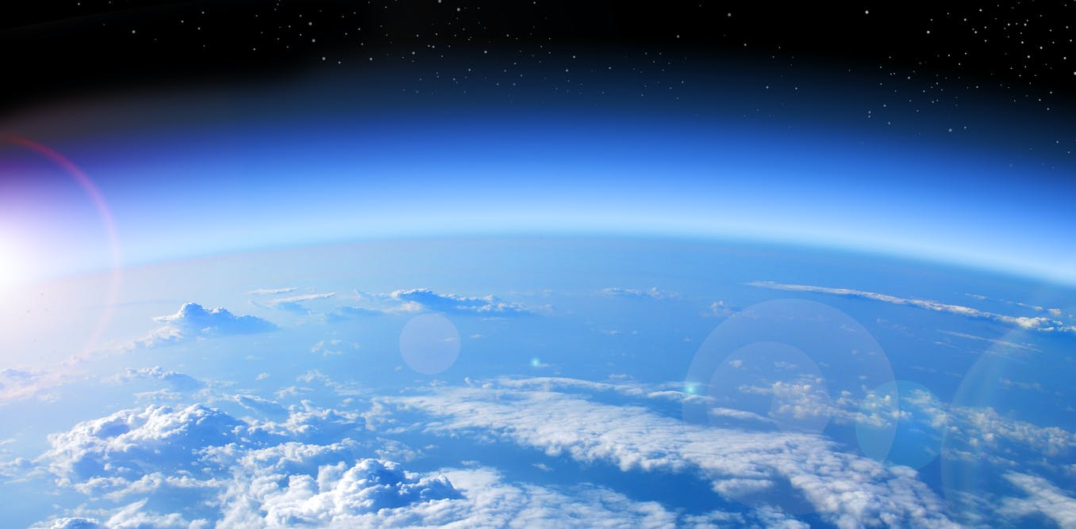
Introduction
Image from The Conversation

Science isn’t just about learning facts!
Have you ever asked why the sky is blue, how rainbows are made or how long would it take to get to Mars? As humans, we are very curious about the world around us and beyond, and it is science that helps our understanding of this.
Science is everywhere. Every aspect of your life is filled with science, from the working of your heart and lungs to the flat-screen TV in your home, to understanding the make-up of the air we breathe!
But science isn’t just about learning a bunch of facts. It is a way of thinking and acquiring skills. This way of thinking is called scientific inquiry. The process of scientific inquiry is how we find answers to our questions and verify those answers. It is what scientists do!
This activity is about exploring key aspects of what scientists do, that is, understanding the nature and practice of scientific inquiry. You will learn about the processes and what is required to present your findings as a scientific report.
The focus of this scientific investigation is air quality at Liverpool, in Sydney, New South Wales. For this investigation, you will use secondary data on atmospheric measurements which were made using a NSW Department of Primary Industries Air Quality Monitoring Station (AQMS) and an ANSTO 1500L dual-flow-loop two-filter radon (²²²Rn) detector on the grounds of Liverpool Girls High School, from March 2019 to February 2020.
So let’s learn about air quality, and what can affect it.

Our atmosphere
The atmosphere is the layer of air that surrounds the earth. An atmosphere, by definition, is the gaseous layer of a celestial body, such as a planet or moon. The atmosphere of the earth is made up of nitrogen gas (N₂, 78%), oxygen gas (O₂, 21%) and argon gas (Ar, ~0.9%). The small remaining fraction of the atmosphere consists of other gases such as carbon dioxide (CO₂) and ozone (O₃), as well as water vapour (H₂O), and of suspended particles in the air (tiny solid or liquid droplets) called aerosols, such as dust, pollen, soot and smoke.
The atmosphere is important for life on earth for a number of reasons. These include:
- providing living things with the gases they need to live,
- sheltering us from the sun’s harmful radiation, including absorbing harmful UV rays
- protecting us from meteoroids, which burn up as they enter the atmosphere
- acting as insulation to keep the temperatures of the earth within a range in which life is possible.
However, the atmosphere is not static. The composition of the atmosphere can change due to emissions of gases and particles from both human and natural sources.

Sources of change
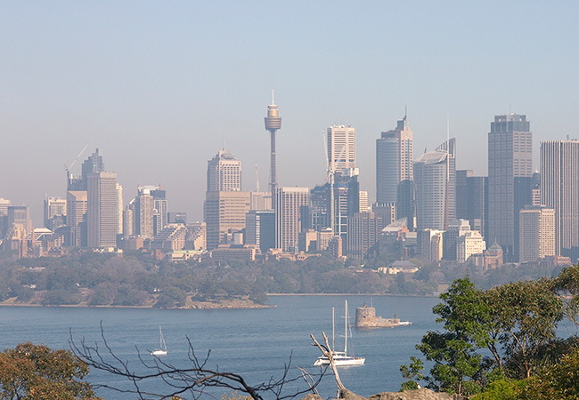
Image from Sydney Air Pollution Health Alert 2017

Humans significantly change the atmosphere by releasing CO₂ into the air from the combustion of fossil fuels like coal, petrol and natural gas. Since the industrial revolution, when humans began to burn fossil fuels in large quantities, the concentration of CO₂ in the atmosphere has increased from about 280 parts per million to over 400 parts per million! Though CO₂ makes up only a small fraction of the total atmosphere, this change has had significant impact on the earth’s climate.
Natural sources also change the earth’s atmosphere. In 1991, a volcano called Mount Pinatubo erupted in the Philippines, ejecting ash, dust and gas into the atmosphere. Strong winds high in the atmosphere spread these gases and particles throughout the globe, causing greater absorption of sunlight in the atmosphere, and resulting in a decrease in the annual mean temperature over the following months. These are examples of how human and natural sources can change the atmosphere, leading to a change in climate. However, atmospheric changes can also impact human health.

Air quality
The atmosphere and human health interact when humans breathe in atmospheric pollutants which are detrimental to the functioning of the human body. Measurements of these pollutants are called air quality measurements and are commonly taken in many cities around the world. There is a lot of scientific evidence proving that many pollutants found in cities can have an impact on the respiratory and cardiovascular systems. The United Nations has labelled poor air quality “the most important environmental health risk of our time”, as it estimates seven million people per year die around the world from diseases related to air pollution.
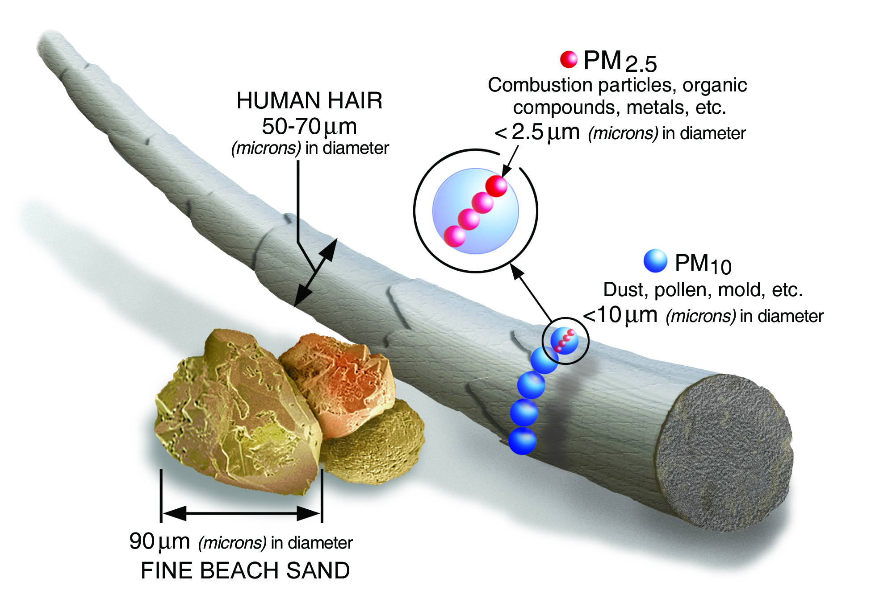

The air quality in Sydney is good compared to some other cities around the world. However, even in Australia, where we are proud of our clean air, there is evidence of negative health impacts on the populations. The pollutants of most concern in Sydney are atmospheric particles and ozone. These atmospheric particles are measured as PM_{2.5} which stands for particulate matter smaller than 2.5 microns across. That’s pretty small! So small, in fact, that 20 of these particles could fit across one single human hair!
Figure from US EPA
Scientists also measure PM₁₀, which are particles smaller than 10 microns across.
The other pollutant of concern is ozone. Ozone is made of three oxygen atoms joined together and its chemical formula is O₃. In the stratosphere, which is the layer of the atmosphere between ~ 15 km and ~ 55 km above the Earth’s surface, ozone is useful because it acts like a planetary sunscreen, blocking harmful UV radiation from the sun. Close to the Earth’s surface, however, ozone is a pollutant that can cause respiratory illness and smog. Ozone is not directly emitted into the atmosphere. Instead, it is formed when other pollutants, like NO₂, interact with sunlight.
Western Sydney is of special importance because some pollutants, especially particulates, are found there at higher concentrations than in other parts of the city. It is also a place where the population is growing, which means poor air quality there could impact a lot of people. Therefore, it is a good place to take some atmospheric measurements!

Measuring Air Quality
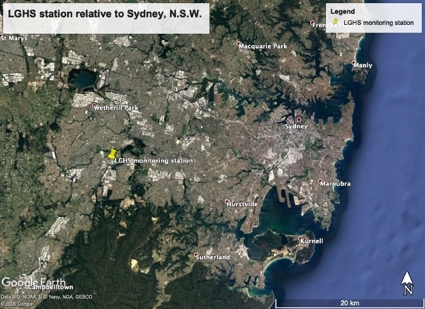
Air quality is assessed by measuring the pollutants in the air using a set of instruments located in an air quality monitoring station (AQMS). There is a whole network of stations like this around New South Wales, constantly reporting on the air quality. The measurements are presented on the NSW Government Department of Planning, Industry and Environment website: dpie.nsw.gov.au/air-quality.
From February 2019 until March 2020, an AQMS was installed on the grounds of the Liverpool Girls High School.
Air quality pollutants, which included PM_{2.5}, PM₁₀, ozone and oxides of nitrogen (NO_{x}), were measured every hour over a twelve-month period, along with weather-related variables like temperature, wind speed and wind direction. The spreadsheet shows the monthly average for each of these pollutants and variables.
Measuring PM_{2.5} involves drawing a sample volume of air into a device called a Beta Attenuation Monitor. Fine particles with a diameter of 2.5 microns or smaller in this volume of air are captured on a glass fibre filter tape. A beam of radiation called beta radiation is passed through a defined spot on the filter to a detector. Fine particles on the filter absorb the radiation, so the radiation coming from the sample is not as strong or intense as the radiation entering the sample. This is similar to the way that sunglasses block sunlight, and so reduce the brightness of the sunlight entering your eyes. The loss of radiation through the filter indicates the amount of fine particles deposited on the filter.
Ozone concentration in the air is measured in a similar manner using ultraviolet light. A sample volume of air is drawn into a cell where a beam of ultraviolet light is passed through it to an ultraviolet detector. Any ozone in the sample absorbs ultraviolet light, just as the ozone does in the stratosphere, so the UV light coming from the sample is not as intense or bright as the UV light entering the sample. This difference provides a measure of the amount of ozone in the sample.
Further details of measurements and instrumentation can be found on the DPIE website.

Planning
Before you begin your investigation, you are going to try to make sense of some observations by researching what is known from secondary sources. This research will form your Background information.

- Can you think of two sources (one human and one natural) of air quality pollutants that affect the city of Sydney?

…………………………………………………………………………………………………………………………………………………………………………………………………………………………………………………………………………………………………………………………

- Can you remember a time when you have noticed the air quality was bad where you live? Maybe there was a strong smell in the air, the air was hazy, or you noticed you were having trouble breathing? Describe a possible source for the pollution at this time.

…………………………………………………………………………………………………………………………………………………………………………………………………………………………………………………………………………………………………………………………
…………………………………………………………………………………………………………………………………………………………………………………………………………………………………………………………………………………………………………………………

Research Question
Does the fine particle (PM_{2.5}) concentration in the air at Liverpool Girls High School remain the same throughout the year?

Background Information
Background information briefly outlines scientific theory and information relevant to your investigation.
So let’s learn more about PM_{2.5}, which are commonly found in smoke and haze, and find out how these fine particles get into the air we breathe.

Use the information presented in the introduction and from the following websites to answer the questions below.
- https://www.epa.vic.gov.au/for-community/environmental-information/air-quality/pm25-particles-in-the-air (watch the short video on PM_{2.5})
- https://www.health.nsw.gov.au/environment/air/Pages/particulate-matter.aspx
- https://cms.environment.nsw.gov.au/topics/air/nsw-air-quality-statements/air-quality-special-statement-spring-summer-2019-20/pm25-particles
- https://www.abc.net.au/news/2020-01-13/monday-morning-briefing-january-13/11861250 Gospers Mountain fire
- https://www.youtube.com/watch?v=qWR_V3f02K8 Video: Fine particle pollution peaks during bushfires

- What are fine particles (PM _{2.5})? Name some examples.

…………………………………………………………………………………………………………………………………………………………………………………………………………………………………………………………………………………………………………………………
…………………………………………………………………………………………………………………………………………………………………………………………………………………………………………………………………………………………………………………………

- Name some ways in which fine particles (PM_{2.5}) get into the air we breathe?

…………………………………………………………………………………………………………………………………………………………………………………………………………………………………………………………………………………………………………………………
…………………………………………………………………………………………………………………………………………………………………………………………………………………………………………………………………………………………………………………………

- What are some of the potential health effects of fine particle (PM_{2.5}) air pollution?

…………………………………………………………………………………………………………………………………………………………………………………………………………………………………………………………………………………………………………………………
…………………………………………………………………………………………………………………………………………………………………………………………………………………………………………………………………………………………………………………………

- What significant event occurred in NSW at the end of 2019 and beginning of 2020? How might this event have affected PM_{2.5} levels in the air at Liverpool Girls High School during this time?

…………………………………………………………………………………………………………………………………………………………………………………………………………………………………………………………………………………………………………………………
…………………………………………………………………………………………………………………………………………………………………………………………………………………………………………………………………………………………………………………………

- Visit the NSW DPIE web page linked above (dpie.nsw.gov.au/air-quality). Click on the “Learn More” button at the bottom of the Air Quality table.
In which place in NSW is the PM2.5 air pollution the highest at the moment? In which place(s) in NSW is the PM2.5 air pollution the lowest at the moment?
(Units are micrograms per cubic metre, µg m⁻³)
Note: a negative PM2.5 value indicates a calibration error for that instrument.

…………………………………………………………………………………………………………………………………………………………………………………………………………………………………………………………………………………………………………………………

- Look at a map showing the location of the air quality stations across Sydney. (dpie.nsw.gov.au/air-quality/air-quality-maps/sydney-map).
Under each station you should see a “PM2.5” category.
- At which station is the PM2.5 concentration the highest? What is the concentration there? (Units are micrograms per cubic metre, µg m⁻³)
Note: a negative PM2.5 value indicates a calibration error for that instrument.
- Approximately how far is this station from the coast? Use the scale at the bottom of the map to estimate this distance.

…………………………………………………………………………………………………………………………………………………………………………………………………………………………………………………………………………………………………………………………

- Can you think of a reason why the air quality might be different in eastern Sydney suburbs which are near the coast compared to western Sydney suburbs which are further away from the coast?

…………………………………………………………………………………………………………………………………………………………………………………………………………………………………………………………………………………………………………………………
……………………………………………………………………………………………………………………………………………………………

Title: | An investigation into PM_{2.5} concentrations at Liverpool Girls High School from March 2019 to February 2020

Aim:
The aim is a simple statement, often starting with ‘to investigate’, that states what you are setting out to do.

Using the information provided in the title, write an aim for your investigation. Remember, your aim should state the dependent variable, which is measured, and the independent variable, which is changed.

…………………………………………………………………………………………………………………………………………………………………………………………………………………………………………………………………………………………………………………………

Hypothesis:
An hypothesis is a testable statement that describes a relationship between the independent and dependent variables. It is a statement of what you expect to find from carrying out the investigation.

Think about the different sources of PM_{2.5} in the atmosphere and propose an hypothesis about PM_{2.5} concentrations throughout the year. In which month do you think PM_{2.5} concentrations will be highest? In which month do you think PM_{2.5} concentrations will be lowest? Why?

…………………………………………………………………………………………………………………………………………………………………………………………………………………………………………………………………………………………………………………………
……………………………………………………………………………………………………………………………………………………………

Method:

The method is a recount of the actions performed to conduct the experiment, written in passive voice and simple past tense. It discusses what was done, how it was done and the equipment that was used.

- Using the information presented in the introduction, describe how PM_{2.5} was measured for this investigation.

…………………………………………………………………………………………………………………………………………………………………………………………………………………………………………………………………………………………………………………………
……………………………………………………………………………………………………………………………………………………………
…………………………………………………………………………………………………………………………………………………………………………………………………………………………………………………………………………………………………………………………
……………………………………………………………………………………………………………………………………………………………

- Using the words below, label the diagram to show how the amount of PM_{2.5} in each of the air samples is determined.

glass fibre filter tape, incident beta radiation, detector, PM_{2.5} , transmitted beta radiation,
beta radiation source.
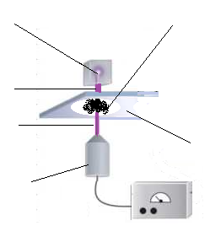
- (i) Identify the independent and dependent variables for this investigation.
- State THREE variables that need to be controlled (kept constant) when making the PM_{2.5} measurements to ensure fair testing.

independent variable  What is changed | dependent variable  What is measured | Controlled variables  What needs to be kept the same

Results:
The results describe what was observed and measured, and the trends discovered by conducting this investigation. Results data is best presented using an appropriate graph, because it is easier to see patterns and trends in data when it is displayed visually compared to when it is shown in a table.

For this investigation, you have been provided with air pollution data in an accompanying MS Excel spreadsheet ‘Atmospheric Measurements at Liverpool Girls HS’. This data was gathered from March 2019 until February 2020, using an Air Quality Monitoring Station (AQMS) that was installed on the grounds of the Liverpool Girls High School.

- Use MS Excel to construct a column graph of the monthly mean PM2.5 concentrations (measured in micrograms per cubic metre, µg m⁻³) at Liverpool Girls High School throughout the year March 2019 - February 2020.
Give the graph an appropriate title and label each axis appropriately. Include your graph in the space below, along with an appropriate heading.

HINT: Perform the following steps to produce the graph using the data from the “LGHS_mean monthly pollutants” tab:
- Highlight the 12 monthly mean PM2.5 values in column D by clicking on cell D2 and dragging the cursor to cell D13.
- Holding down the “Command” or “Control” key, click on cell A2 and drag the cursor to cell A13 to highlight the 12 months over which the investigation was conducted in column A.
- Click the insert tab, click insert column graph from the Charts shown, then click on the first 2-D column graph in the dialog box (Insert -> Chart -> 2D column)
- Click on your chart. Click Chart Design tab, then click Add Chart Element (Chart Design -> Add Chart Element). Scroll down to highlight Chart Title, then click Above Chart. Type an appropriate title for your graph then press enter.
- Click on Add Chart Element, scroll down to highlight Axis Titles, then click Primary Horizontal and type an appropriate label.
- Click on Add Chart Element, scroll down to highlight Axis Titles, then click Primary Vertical and type an appropriate label. Don’t forget to include the units.

Figure 1: Write a useful heading for your graph.
……………………………………………………………………………………………………………………………………………………………

Copy your chart from MS Excel and paste it here.

- Describe your results. How does the mean concentration of PM_{2.5} vary with the time of year, for example, the seasons? When is the PM_{2.5} concentration the greatest?

…………………………………………………………………………………………………………………………………………………………………………………………………………………………………………………………………………………………………………………………
……………………………………………………………………………………………………………………………………………………………
…………………………………………………………………………………………………………………………………………………………………………………………………………………………………………………………………………………………………………………………
Discussion:
The discussion analyses and interprets the results of the investigation. For example, patterns, causal relationships, errors and limitations are identified and explained. The discussion also positions the results of the investigation in context with previous research and background knowledge. Evidence-based arguments are constructed, making links between what was observed in the investigation and the scientific theory or concepts. The discussion may also address implications of the findings and propose further research or action.

The following questions will help you to analyse and explain your results and to better understand the effects of meteorological events on fine particle air pollution.

- Using your background information, explain what the investigation results show. Suggest a possible reason why there is a significant increase in the mean concentration of PM_{2.5} in certain months, indicated by the results.

…………………………………………………………………………………………………………………………………………………………………………………………………………………………………………………………………………………………………………………………
……………………………………………………………………………………………………………………………………………………………
……………………………………………………………………………………………………………………………………………………………

- What do the investigation results mean for the people of Liverpool?

…………………………………………………………………………………………………………………………………………………………………………………………………………………………………………………………………………………………………………………………
……………………………………………………………………………………………………………………………………………………………
…………………………………………………………………………………………………………………………………………………………………………………………………………………………………………………………………………………………………………………………

- Look at the rainfall data from Bankstown Airport Weather Station here. What is the mean February rainfall (located at the bottom of the page)? What was the rainfall in February 2020?

…………………………………………………………………………………………………………………………………………………………………………………………………………………………………………………………………………………………………………………………

- Look at your results graph. What happens to PM_{2.5} concentrations at Liverpool in February 2020 compared to the proceeding two months? Suggest a reason for the change.
Hint: think about the previous question for a clue.

…………………………………………………………………………………………………………………………………………………………………………………………………………………………………………………………………………………………………………………………
……………………………………………………………………………………………………………………………………………………………
……………………………………………………………………………………………………………………………………………………………
……………………………………………………………………………………………………………………………………………………………
- Air quality pollutants like PM_{2.5} can be transported from their sources to influence air quality at places hundreds of kilometres away.
Name two sources of PM_{2.5} air pollution. How do you think pollution from these sources reaches distant places?

…………………………………………………………………………………………………………………………………………………………………………………………………………………………………………………………………………………………………………………………
……………………………………………………………………………………………………………………………………………………………

- Suggest the possible effect of two meteorological phenomena (weather events), for example strong winds, heavy rain or an inversion layer, on the air quality in Liverpool, which has a variety of fine particle (PM_{2.5}) air pollutant sources.
An inversion layer occurs when a warm layer of air is a above a layer of cooler air close to the Earth’s surface. The warm layer of air acts like a lid trapping the cooler air at the surface, instead of allowing this air to rise higher in the atmosphere and disperse.

…………………………………………………………………………………………………………………………………………………………………………………………………………………………………………………………………………………………………………………………
……………………………………………………………………………………………………………………………………………………………
…………………………………………………………………………………………………………………………………………………………………………………………………………………………………………………………………………………………………………………………
……………………………………………………………………………………………………………………………………………………………

- What are some things that could be done to reduce fine particle air pollution in the air we breathe?

…………………………………………………………………………………………………………………………………………………………………………………………………………………………………………………………………………………………………………………………
……………………………………………………………………………………………………………………………………………………………
…………………………………………………………………………………………………………………………………………………………………………………………………………………………………………………………………………………………………………………………
……………………………………………………………………………………………………………………………………………………………

- This investigation collected fine particle PM_{2.5} air pollution measurements at Liverpool Girls High School over a 12 month period from March 2019 to February 2020. How could you extend this investigation to confirm the pattern or trend shown by these measurements?

…………………………………………………………………………………………………………………………………………………………………………………………………………………………………………………………………………………………………………………………
……………………………………………………………………………………………………………………………………………………………
Conclusion:
A conclusion is like an answer to your aim. It provides a brief summary of the findings of the scientific investigation. It does not introduce new information.

Write a conclusion for your experiment. Do the results support your hypothesis?

…………………………………………………………………………………………………………………………………………………………………………………………………………………………………………………………………………………………………………………………
……………………………………………………………………………………………………………………………………………………………
………………………………………………………………………………………………………………………………………………………………………
……………………………………………………………………………………………………………………………………………………………
………………………………………………………………………………………………………………………………………………………………………

Extension Activity: Investigating ozone concentrations

The ozone layer found high in the upper atmosphere (the stratosphere) is beneficial for humans and other living things as it shields us from much of the sun's ultraviolet radiation. However, ozone at ground level where we can breathe it can cause serious health problems.

Let’s learn more about this gas, how it forms in the lower atmosphere, how breathing ozone may affect us, and whether the seasons of the year have any effect on the concentration of ozone in the air we breathe.

Research question:
Does the ozone concentration in the air at Liverpool Girls High School remain the same throughout the year?

For this investigation, we will use data in the accompanying MS Excel spreadsheet ‘Atmospheric Measurements at Liverpool Girls HS’, which provides the mean monthly ozone concentration measured using an Air Quality Measuring Station (AQMS) located at Liverpool Girls High School from March 2019 until February 2020.

- Research ‘tropospheric ozone’. The following website is useful. You will also need to find two more sources of information that you can use. Record your sources in the table below.

1 | https://scied.ucar.edu/learning-zone/air-quality/ozone-troposphere
2
3

Use the information you gather from your research to answer the following questions:

- What is ozone?

………………………………………………………………………………………………………………………………………………………………………………………………………………………………………………………………………………………………………………………………………………………………………………………………………………………………………………

- How is ground level ozone formed?

………………………………………………………………………………………………………………………………………………………………………………………………………………………………………………………………………………………………………………………………………………………………………………………………………………………………………………
………………………………………………………………………………………………………………………………………………
………………………………………………………………………………………………………………………………………………
- Around what time of day would ozone levels in the atmosphere be highest? Give a reason for your answer.

………………………………………………………………………………………………………………………………………………………………………………………………………………………………………………………………………………………………………………………………………………………………………………………………………………………………………………
………………………………………………………………………………………………………………………………………………
………………………………………………………………………………………………………………………………………………

- What are some of the health effects of ozone pollution?

………………………………………………………………………………………………………………………………………………………………………………………………………………………………………………………………………………………………………………………………………………………………………………………………………………………………………………
………………………………………………………………………………………………………………………………………………
………………………………………………………………………………………………………………………………………………

- At which time of year is ozone concentration in our air likely to be greatest? Why?

………………………………………………………………………………………………………………………………………………………………………………………………………………………………………………………………………………………………………………………………………………………………………………………………………………………………………………
………………………………………………………………………………………………………………………………………………
………………………………………………………………………………………………………………………………………………

- How are we able to measure ozone levels in the air we breathe? Use the information presented in the introduction to describe how ozone concentration was measured for this investigation.

………………………………………………………………………………………………………………………………………………………………………………………………………………………………………………………………………………………………………………………………………………………………………………………………………………………………………………………………………
………………………………………………………………………………………………………………………………………………………
………………………………………………………………………………………………………………………………………………………

- (a) Construct a column graph of the mean monthly ozone concentration at Liverpool Girls
High School throughout the year March 2019 – February 2020 using the data from the “LGHS_mean monthly pollutants” tab:
(HINT: use the same instructions provided on page 10 of this resource to construct your graph using MS Excel)
Figure 2: Write a useful heading for your graph.
………………………………………………………………………………………………………………………………………………………

Copy your chart from MS Excel and paste it here.

- Describe this graph and explain any observed trends.

………………………………………………………………………………………………………………………………………………………………………………………………………………………………………………………………………………………………………………………………………………………………………………………………………………………………………………………………
……………………………………………………………………………………………………………………………………………………
……………………………………………………………………………………………………………………………………………………
……………………………………………………………………………………………………………………………………………………
……………………………………………………………………………………………………………………………………………………

- (a) Investigate the relationship between average monthly temperature and the concentration of ozone in the atmosphere. To do this, create a scatter plot with average monthly temperature on the x-axis and mean monthly ozone concentration on the y-axis.

Hint: Perform the following steps to produce this graph.
- Highlight the 12 monthly mean temperature values in column C by clicking on cell C2 and dragging the cursor to cell C13.
- Holding down the “Command” or “Control” key, click on cell F2 and drag the cursor to cell F13 to highlight the 12 mean ozone values in column F.
- Click the insert tab, click insert scatter (X,Y) graph from the Charts shown, then click on the first scatter graph in the dialog box (Insert -> Chart -> Scatter)

- Click on your chart. Click Chart Design tab, then click Add Chart Element (Chart Design -> Add Chart Element). Scroll down to highlight Trendline then click linear.
- Click on Add Chart Element, scroll down to highlight Chart Title, then click Above Chart. Type an appropriate title for your graph then press enter.
- Click on Add Chart Element, scroll down to highlight Axis Titles, then click Primary Horizontal and type an appropriate label.
- Click on Add Chart Element, scroll down to highlight Axis Titles, then click Primary Vertical and type an appropriate label. Don’t forget to include the units.

Figure 3: Write a useful heading for your graph.
……………………………………………………………………………………………………………………………………………………………

Copy your chart from MS Excel and paste it here.

- Does this graph provide evidence in support of your explanation of a seasonal pattern for the mean monthly ozone concentration at Liverpool Girls High School?

…………………………………………………………………………………………………………………………………………………………….…………………………………………………………………………………………………………………………………………………………….…………………………………………………………………………………………………………………………………………………………….
…………………………………………………………………………………………………………………………………………………………….
…………………………………………………………………………………………………………………………………………………………….

You may like to write up this investigation in the form of a scientific report. Follow the step-by-step scaffold, using the headings provided in this document, to present your investigation.

Further investigations
There are many other scientific investigations that could be carried out using the data presented in the MS Excel spreadsheet ‘Atmospheric Measurements at Liverpool Girls HS’.
Below are some suggested research questions for investigations that can be completed using this data, or you could come up with your own!
Follow the step-by-step scaffold of a scientific report, provided on the previous pages to communicate your investigation.

- Does the hourly ozone concentration in the air at Liverpool Girls High School remain the same throughout the day?

- Does the hourly PM_{2.5} concentration in the air at Liverpool Girls High School remain the same throughout the day?

- Does the hourly NO₂ (nitrogen dioxide) concentration in the atmosphere at Liverpool Girls High School remain the same throughout the day?

- Is there a relationship between the concentrations of ozone, PM_{2.5} and nitrogen dioxide in an urban atmosphere?

