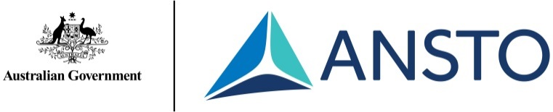

Chemical World Primary Incursion for Stages 2 and 3
Incursion Outline
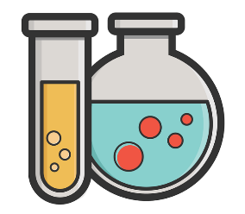

Your incursion
Offered to local primary schools in the St George and Sutherland Shire regions of Southern Sydney.

The Chemical World Primary Incursion is delivered to your classroom by two experienced and passionate educators with science qualifications and specialised knowledge and experience in chemistry.

Requirements for this incursion are as follows:
- Students work mostly at their desks
- Students work in pairs
- A pencil or pen to fill in worksheets
- Space on the classroom floor to build a large protein molecule (time permitting)
- Technology for PowerPoint presentation

For further enquiries or to book this incursion, contact the ANSTO Education Team:
Phone: 02 9717 3090 email: tours@ansto.gov.au

Overview
Students observe how objects are made up of smaller parts with the use of small magnifiers and microscopes. They learn that everything– all solids, liquids and gases - are made up of atoms and their size and shape are considered. We discuss different kinds of atoms and introduce the Periodic Table as a list of atoms. Students learn that atoms can exist by themselves (elements) or with other atoms.
In the second hands–on activity, students are given solid element samples and use a small balance to arrange them in order of weight. We discuss the results and compare them to the Periodic Table.
For the remainder of the incursion students use tactile atomic kits to join atoms together to make “molecules”. They make familiar substances, such as water and carbon dioxide, and then progress through a series of activities building substances of increasing complexity and size. If time permits, the whole class participates in constructing a large protein molecule.
This is a fun and engaging introduction to the chemicals in our world and the content is accessible for different learning abilities. It is assumed that students have no or very limited prior knowledge of the concepts of atoms and the Periodic Table.
The content provided in this incursion was developed by Ian Stuart, founder of the Atomic School for primary students. It has been successfully delivered in many primary schools and is supported by current research. More information and additional supporting material and resources for teachers can be found here: www.AtomicSchool.com

Format Summary
Component | Suggested timings (mins)
Introduction | 10
Activity 1: Observations with magnifiers and microscopes | 15
Activity 2: Weighing elements | 20
Activity 3: Building chemical substances (molecules) | 45
Additional time for learning/discussion/ quizzes (recommended) | 30

The incursion is 1.5 or 2 hours in duration and has been successfully run in the first, second and third sessions of the school day.

Group size: Student numbers are limited to 30

Content Summary:
- Atoms and elements
- Periodic Table
- Common chemicals
- Making molecules

Links to NSW syllabuses

NSW Science and Technology K-6 Syllabus (2017)

Stage 2 - Material World
Changes of state
- identify solids, liquids and gases as states of matter SciT
- describe examples of changes of state in everyday life SysT
Materials are used for a specific purpose
- investigate how the properties of natural and processed materials influence their suitability and use in products, services and/or environments, for example: (ACSSU074, ACTDEK013) DesT SciT – elasticity − thermal conductivity

Stage 3 - Material World
States of matter
- investigate and compare the properties of solids, liquids and gases (ACSSU077) SciT
Mixtures
- explore that when materials are combined the result is either a mixture or a new substance, for example: (ACSSU095) SciT − salt and water − bicarbonate of soda and vinegar
_________________________________________________________________________

